**Name**: Samaa Maged Ahmed

**B.N**: 396

**Topic**: Mobile computing

**GitHub Link**:

# Mobile computing

-Mobile computing is the field of wireless communication and carryaround computers, Such as laptop computers. In some ways the mobile computing field spun out of work initialized within the ubiquitous computing area. Likewise, The early focus on wireless networking led to wireless communication mechanism research. Work on these mechanisms began in the mid-1980s and led up to the standards around wireless local area networks (WiFi) that started forming in the late 1990s. The field of mobile computing has benefited greatly from the technical advances in computing technology such as low-power PC processors , Small-size digital memory technology, And inexpensive display systems. The combination of those technologies has created the field of laptop computing, Which has led to the creation of the new class of inexpensive laptops called netbooks, Netbooks are designed with wireless communication in mind.

Mobile computing has further permeated wireless network access. Today, so-called WiFi hot spots at public places such as coffee houses, Libraries, And airports are common. Users may connect to the internet through this wireless network either gratis or for a fee.

**Source Code**

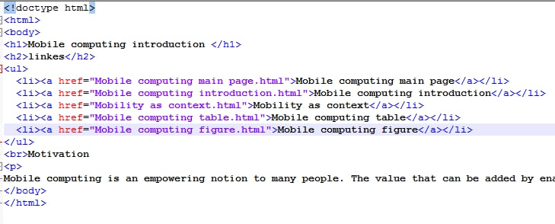

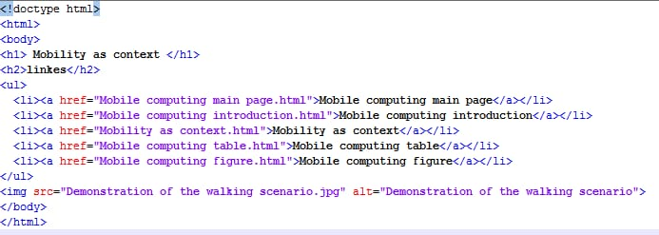

**Screenshots**

